**Domestic violence**

# How can you defend yourself? Where can you get help?

#### **Information in simple language**

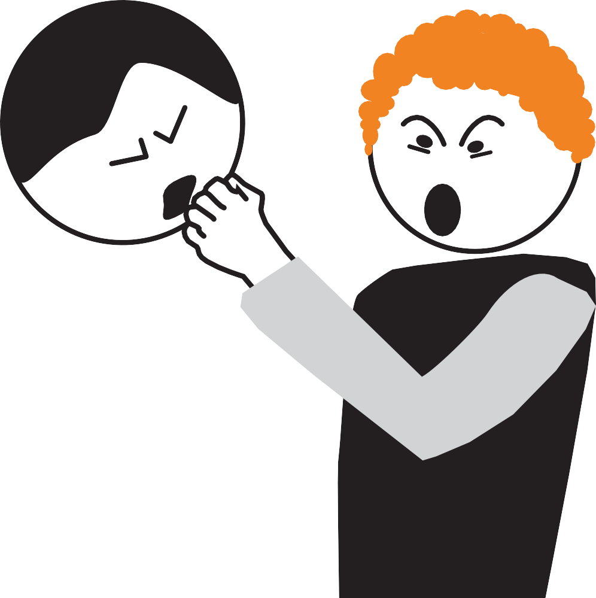

**Domestic violence means: violence in the private sphere**



The Ministry of Social Affairs, Integration and Equality of Mecklenburg-Vorpommern / Head Office for Women and Equality

has supported this brochure with money.

**Domestic violence**

# How can you defend yourself? Where can you get help?

**Information in simple language**

## **This booklet provides information about domestic violence.**

###### **Domestic violence means:**



The violence happens in private. You know the person of violence.

###### **Defend yourself against domestic violence**



**Courage**

Domestic violence disrupts your life. Domestic violence makes you sick.

Domestic violence affects partners.

But domestic violence is **not a** private matter! Domestic violence is a criminal offence.

The law protects victims.

You can claim your protection rights.

**Who is affected by domestic violence?**

It can be:

* People who have to endure violence themselves. These people are **victims**.
* Relatives and acquaintances of victims.

These people suffer from the acts of violence.

* Children of victims are particularly affected. Victims can be women, men and children.

4

###### **The booklet provides answers to the questions:**

?

* + What is domestic violence?
  + How can you protect yourself?
  + Where can you get help?
  + How does the law protect against acts of violence? The information is for women and men.

##### Where can you get advice and help?

?

Many advice centres and help facilities support victims of domestic violence. Do you feel affected?

Let us advise you!

Addresses are at the end of this booklet. Choose an address near your home.

###### **Domestic violence is done by partners.**



Partner means: you know the violent person well.

Partners can be life partners.

The partners can also be relatives or friends. Is the word "partner" in this booklet?

Then male partners or female partners can be meant.

Men or women do violence.

That's why in this booklet it always says: Violent Person.

5

**What is in this booklet?**

This booklet provides information about domestic violence. 4

What is domestic violence? 9

Domestic violence affects many people. 10

Argument or violence - how can you tell the difference? 12

What does quarrel mean? 12

What does violence mean? 14

The violence can happen again and again. 16

Domestic violence has many expressions. 18

**Domestic violence always affects the children. 38**

Parents separate. What about the children then? 40

This is important for an affected child. 42

Where can you and your child get help? 43

Harassing or following persons again and again:

It is called stalking44

What can you do against stalking? 46

Protection and help in the event of stalking49

Threatening or insulting on the internet:

This is called cyber-stalking50

How can you protect yourself from cyber stalking? 56

Are you affected? What can you do? 58

**What can you do against domestic violence? 61**

A life without violence is possible62

What should you always do when you are affected? 64

Emergency medical assistance68

They have a right to protection from violence71

The Violence Protection Act72

How can you claim your right to protection? 73

What happens in trial? 80

**What protective measures are there for those affected? 85**

What protection options do the police have? 87

What protections does the court have? 90

**Where can victims get advice and protection? 95**

Emergency telephones97

Various advisory services 100

Addresses of advice centres123

**Help for this booklet143**

Memo 144

Packing list in an emergency 147

Where are explanations in this booklet? 150

# What is domestic violence?

**Domestic violence affects many people.**

#### **Stand up against the violence!**

###### **Domestic violence is done by people you know.**

For example:

* Life Partners
* Ex-partners
* Next of kin
* Boyfriends or girlfriends

###### **Domestic violence happens in places you know well**

For example:

* Home
* In a dorm
* In a daycare center
* In other places you know well. Domestic violence happens on the Internet too.

**Anyone can be affected.**

Domestic violence exists against women and against men.

Women with handicaps are particularly often affected.

**The violence person is friendly**

##### to other people.

The violent person may be friendly to neighbors or mutual acquaintances.

Many violent persons are only violent towards the victims.

Others, therefore, do **not** notice the distress of those affected. This is difficult for those affected.

But it is always the violent person who is guilty.

Are you affected?

?

Be self-confident!

The violent person is guilty. Get advice!

###### **Domestic violence makes you sick**

Domestic violence has horrible consequences for those affected. These can be consequences:

* + Persons affected sleep poorly.
  + Persons affected are afraid.
  + Persons affected are desperate.
  + That is why some persons affected hurt themselves. For example: they carve themselves with a knife.
  + Suicide
  + Persons affected have eating disorders.
  + Affected women are pregnant,

because the violent person forced sex.

**Dsipute or violence - How can**

# you tell the difference?

### What does dispute mean?

###### **The parties involved are about equal in strength.**

People have different opinions. That is a good thing.

But people need to have understanding for other opinions. Do people **not** have **enough** understanding?

Then there can be a fight.

**An argument involves 2 or more people.**

Dispute means: The parties involved speak with one another.

But the parties involved have different opinions. Therefore, the parties involved have to find a **compromise. Compromise** means: a solution that is good for everyone.

An argument can be very violent.

Maybe the participants are shouting and insulting. Maybe the participants are violent.

But the parties involved are about equal. Therefore, a compromise is possible.

**An example of a dispute in a partnership**

A partner wants to save money.

The other partner wants to buy expensive furniture. That is why the partners quarrel.

Maybe the partners can resolve the dispute that way:

The partners buy less expensive furniture together. Or the partners save money first.

Then the partners buy new furniture together.

### What does violence mean?

###### **A partner wants to be stronger.**

Violence is more than fighting.

Violence means: One partner wants to be stronger.

One partner wants to determine and control everything. Therefore, this partner forces with pressure.

This is violence.

The violence frightens the other.

**Violence can be very different.**

For example:

* punch or kick
* touch or sex, if you do **not** want to do it yourself
* yell at you or insult you over and over again
* Pressure with money matters

**An example of violence in a partnership**

Petra and Klaus are life partners. Petra wants to save money.

Klaus wants to buy a new car. Klaus wants to take money for the car.

Klaus **doesn't** get the money? Then Klaus uses violence.

The violence scares Petra. And she gives the money.

Klaus wields power.   
This can **not** be happening. Petra needs to fight back.

###### **Stand up against violence!**

?

Let us advise you!

Advice centres for persons affected by violence are

in many places in Mecklenburg-Vorpommern.

Counselors are sympathetic to those affected by violence.

Addresses of advice centres are at the end of this booklet.

**The violence can**

**happen again and again**

Has violence occurred in your partnership? Then it can happen again and again!

This is how many persons affected have experienced it.

###### **After violence often comes a good time.**

The violent person regrets the act of violence. At some point the mood gets worse again. And it comes to violence again.

Perhaps new acts of violence occur more and more quickly. The acts of violence can be worse each time.

###### **The mood in the partnership changes.**

There are calm and peaceful times. Then there are times of new violence.

And those affected must be afraid again.

We call the different times: Phases.

###### **Avoid new violence.**

Talk to people you trust. Let them help you!  
Let us advice you!

?

###### **These are the violent phases**

* + **Phase 1**: The mood between partners is getting worse and worse
  + **Phase 2**: Violence occurs

**In-between time**: many persons affected seek help,

for example with the police or with a doctor.

* + **Phase 3**: The violent person repents.

The mood is calm and peaceful.

* + **Phase 4**: The violent person accuses the victim.
  + **After 4th phase:** Everything starts again.

There is no end to violence

The phases change faster and faster. The circle becomes tighter and tighter.

We call this: **spiral of violence**.

**Domestic violence has many expressions**

**Domestic violence means:**

**A partner wants power and control.**

One partner wants to rule.

That's how violence always starts.

**Violence hurts the victims.**

Wounds or bruises can be seen by others. But violence also hurts feelings.

Others can **not** see that.

Many of those affected remain silent.

That's why others don **not** know about the violence. This is bad.

**Affected persons have problems.** Does an affected person remain silent? Then she has to do everything alone. That makes lonely and sick.

**Have you been affected by violence?**

?

Then talk to people you trust!

Let us advice you!

Addresses of advice centres are at the end of this booklet.

###### **All of these examples can be domestic violence:**

**Physical violence**

The violent person hurts with bodily force.

For example: The violent person punches or kicks.

Mental violence

The violence person disturbs the feelings of victims. Mental violence is for example:

Yelling or insulting at someone.

Violence through sexual acts

The violent person forces sex or touching.

The people involved **don't** want that.

Social violence

The violent person disrupts the togetherness

of persons affected with other people.

decline responsibility

The violent person is guilty.

But the violent person **does not** take responsibility.

Others are therefore affected.

Violence with money matters

The violent person controls money or property.

**Violence only for power and control**

The violent person wants to dominate the victim.

That's why the violent person wants to control everything. That is why the person does violence.

**Violence affecting children**

Do children see and hear violence? Then the children are always affected. Unfortunately, there is also violence against children.

**All of these examples can be domestic violence.**

The image is a circle with different areas.

Each area represents a concept of violence.

##### Violence affecting children

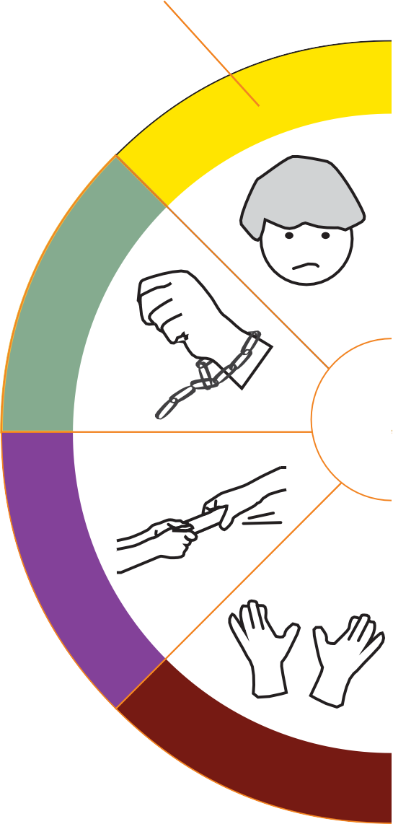

**Violence only for power and control**

**Ma u**

**Kont**

**Violence in money matters**

€

**Decline responsibility**

The beginning of violence always is:

The violent person wants power and control. That's why it says "power and control" in the middle.

##### Physical violence

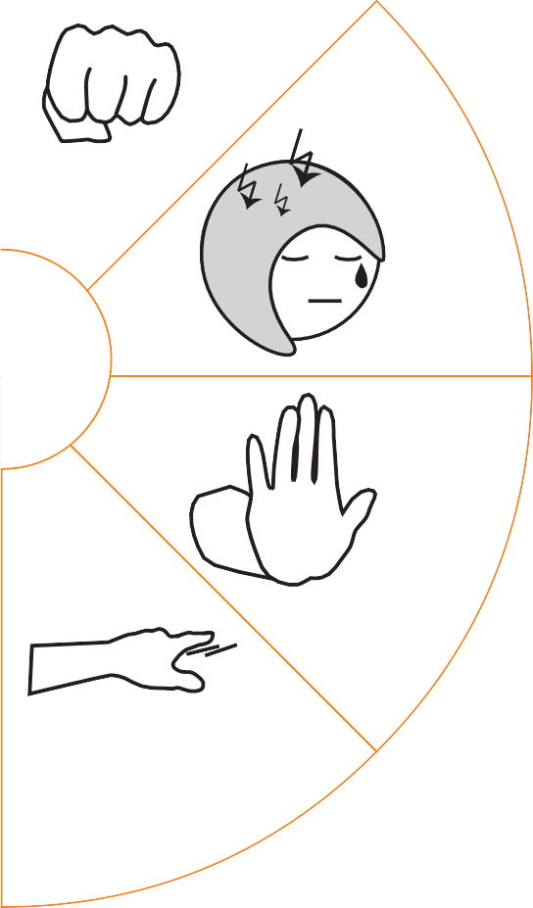

###### **Mental violence**

**cht nd role**

**STOP!**

###### **Violence through sexual acts**

**Social violence**



**That means physical violence:**

The violent person hurts with bodily force.

The violence injures the body of the victim. Injuries are for example open wounds or bruises on the skin.

**Some examples of physical violence:**

* punch, kick or shove
* gag
* pull one's hair
* injure with weapons or knives
* burn with a cigarette

###### **This is important !**

Indicate the injuries:

* + at the **victim outpatient clinic**
  + with a doctor.

The **victim outpatient clinic** is a service for emergencies. Those affected by violence get help quickly. You can **read more about the Victims' Outpatient Clinic on page 68 of this issue.**

Get a doctor's report.

The doctor's report is important evidence later. Therefore, keep the doctor's report in a safe place.

Every doctor has a duty of confidentiality!

You can show all the injuries. You can talk about the violence! Everything remains secret.

###### **Let us advise you!**

?

Addresses of advice centres are at the end of the booklet.



#### **That means mental violence:**

The violent person hurts the feelings of victims. Mental violence can be, for example:

The partner denies love. The partner does this on purpose. This makes the affected person lonely.

This can also be mental violence:

An ex-partner is jealous.

That's why the ex-partner demands attention.

The ex-partner is harassing the victim.

Or the ex-partner threatens.

The affected person is afraid.

The affected person does **not** feel free.

This damages the self-confidence of those affected.

###### **This is important: !**

**An example of mental violence:**

Ina is Otto's ex-partner. Otto still loves Ina.

But Ina has a new boyfriend. Otto is jealous.

Otto watches and follows Ina. This scares Ina.

Ina feels pressure.

Fear and pressure make Ina sick.

Talk about the violence!

Talk to a trusted person.

###### **Let us advise you!**

?

Addresses of advice centres are at the end of the booklet.

**STOP!**

#### **That means violence through sexual acts:**

The violent person forces physical contact.

The victim doesn**'t** want that.

Physical contact includes:

* touch or caress
* kiss
* sex

You wish physical contact?

You want to talk about tenderness and sex? You should always decide that for yourself!

**No one** may force you!

Even your partner must **not** force you!

Violence through sexual acts is called by professionals:

sexualised violence.

**That too is sexualised violence:**

The violent person shows sex pictures or sex movies.

The victim has to watch everything. The victim does **not** want that.

But the violent person uses force. The violent person is afraid.

**Sexual violence unfortunately happens a lot.**

Adults and children are affected. The violent person is always guilty! Victims must protect themselves!

The Violence Protection Act gives us all protection rights.

**Sexual violence often remains secret.**

That's wrong!

The violence must stop!

Are you affected?

Then talk about the violence! Talk to people you trust and to counselors.

**Have courage!**

**Let us advise you!**

?

There are special

Advice centres against sexualised violence.

The employees are professionals. Anyone and everyone can come for advice!

Counselors and advisors do **not disclose** anything.



#### **That means social violence:**

Social violence disrupts the way people live together.

**Example:**

Anna is Paul's life partner. Lisa is a good friend of Paul.

Paul wants to meet Lisa at the movies.

Anna is jealous.

That's why Anna forbids the meeting.

Anna's putting on the pressure.

Anna does this all the time.

Anna does this in other situations too. This way Paul can**'t** meet his friends.

It makes Paul lonely.

**Another example:**

Monika tells lies about Lotte.

Humans therefore have no trust in Lotte.

Lotte finds this embarrassing.

Lotte feels bad in society. Lotte therefore avoids contact.

She gets lonely.

##### Social violence happens in many partnerships.

Social violence also affects friends and acquaintances.

Social violence disrupts friendships.

###### **This is important: !**

**Don't** let them make you look bad. Be self-confident!

Believe in your abilities. Trust your friends.

###### **Let us advise you!**

?

Addresses of advice centres are at the end of this booklet.

#### **That's what "deny responsibility" means:**

The violent person behaves badly. But the violent person blames others.

That's why the others suffer.

The others have worries and problems.

###### **Example:**

Laura piles up a lot of money debts.

But Laura claims:

"Robert has been saving badly. That is why there is little money.

Robert has to pay the debt."

Laura's behavior is bad.

Laura must take responsibility herself. But Laura refuses the responsibility.

Laura blames Robert. That's not fair.

And that offends Robert.

Does this happen all the time? Then it can make you sick.

Does Robert have to pay the debt? Then Robert can get into money trouble. Then Laura is guilty.

**Alcohol does not excuse bad behavior!**

**Another example:**

Frank punched Rita.

Frank says: "I drank a lot of alcohol. That's why I was **not** aware of the violence. So I'm **not** guilty."

Frank denied responsibility. That's wrong.

Alcohol is **not an** excuse. Frank is guilty.

**Your partner rejects responsibility?**

Fight back!

###### **Let us advise you!**

?

Addresses of advice centres are at the end of this booklet.

**€**

#### **This means**

€

**violence in money matters:**

The violent person makes pressure in money matters. Sometimes it is also about property.

For example: It's about the joint car.

One partner controls money and property. Thus, the other can **not** live freely.

The affected partner must therefore defend him- or herself!

Violence in money matters also means:

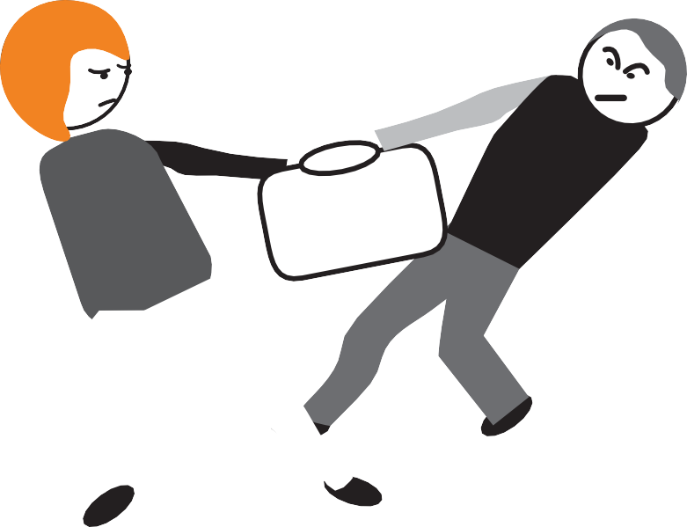

**Economic violence.**

Economic means: it's about money.

**Some examples of economic violence:**

* One partner has money debts.

The other should pay the money debt. Does the other refuse?

Then the partner does violence.

* One partner controls the bank account. The other is **not** allowed to get money him-/herself.
* One partner decides about the car. The other must always ask.
* One partner forces the other to earn money. The other earns the money.

But the other person is **not** allowed to decide for him-/herself about the money.

**This is important: !**

Do **not** pay for the violent person! You want to lend money or things? Always think carefully:

Can you trust the person?

Only then lend the money or things. Do not feel pressured!

**Let us advise you!**

?

Addresses of advice centres are at the end of the booklet.



**This means**

**violence only for power and control:**

Some partners always want to be in charge. These partners want to control everything That's what it's all about.

That's the only reason partners are willing to use violence.

The violent people think only of themselves.

Interests of persons affected do not matter.

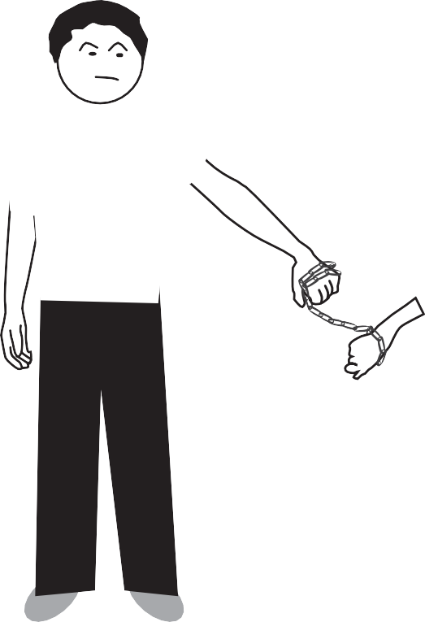

###### **Example:**

Sabine and Klaus are partners. Sabine has saved money.

Sabine decides herself about the money:

Sabine buys a new sofa. This makes Klaus angry.

Klaus wants to rule.

Klaus wants to control all money payments. But Sabine decided alone.

That's why Klaus does **not** want the sofa.

Klaus demands: The sofa must go.

Sabine does **not** bring back the sofa? Then Klaus threatens with violence.

Or Klaus destroys the sofa.

Violence is **not** allowed! Sabine must defend herself!

###### **This is important: !**

**A partner rules your life?**

This can **not be** happening! Fight back!

You decide about your life on your own! That is your right!

###### **Let us advise you!**

?

Addresses of advice centres are at the end of this booklet.

**Violence affecting children**

Does the violent person abuse or threaten a child? Does a child see and hear acts of violence?

It's bad for the child.

A child loves both mother and father. Do the parents fight?

Are the parents fighting?

A child senses the fear of the mother or father.

Then the child him-/herself is afraid. The child has sorrow and worries. All this makes sick.



**This is how a child can be affected:**

* + A child has to watch acts of violence. But the child should remain silent.

The violent person threatens the child.

* + The violent person speaks badly about mother or father. Or about another trusted person.

A child should continue to say the bad words. This strains the feelings of the child.

* + Parents are splitting up.

The parents fight over the child. Father or mother forces the child.

###### **This is important: !**

Protect the child. Talk to the child.

The child needs a trusted person.

Consider:

Who can be the trusted person? The trusted person and the child must get along well.

###### **Let us advise you!**

?

Your child can also get advice.

Addresses of advice centres are at the end of the booklet.

# Domestic violence always affects the children

##### The violence scares the children

Children deal with fear differently. Some children are angry.

Other children are particularly well-behaved. Is one child particularly well-behaved?

Maybe the child is very scared.

Therefore, the child wants to do everything right.

Many children remain silent about the violence. Nevertheless, the children have sorrow and worries.

Some older children take responsibility. The older children protect younger siblings. This overburdens the children.

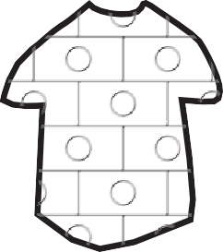

**What consequences can domestic violence have**

##### for a child?

Some examples:

* + The child is often angry.
  + The child learns to speak badly.
  + The child sleeps badly.
  + The child wets the bed in the night.
  + Headache
  + The child does not like much food.
  + The child is anxious.

##### This is how you encourage the child!

Consider:

What does the child feel? What does the child need?

Give the child peace and confidence. Let the child tell.

Listen patiently.

Have the child talk to another trusted person.

Consider:

Who can the child trust particularly well? Support the child in this contact.

**Parents are splitting up.**

##### Then what about the kids?

Children love their mother and father.

Separation is difficult for the children.

Therefore, children need understanding and support.

Maybe the parents have different opinions. This is difficult for a child.

The child is then insecure.

Maybe the child is acting strangely. Or the child is behaving particularly well. Every child deals with a separation differently.

Take care of the child! Ask yourself: What does the child feel? Talk to the child.

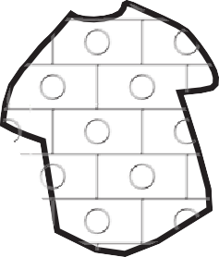

##### Every child has the right

###### **to a life without violence**

**BOOK VIII OF THE SOCIAL CODE**

**§8a**

The law protects children from violence.

The father or mother is violent?

These are bad living conditions for a child.

In the law, it's called **child welfare endangerment**.

Is the child's welfare at risk?

Then the child must be given protection.

A family court decides on protective measures.

The family court may prohibit the violent person:

* + to come to the family apartment and
  + to visit the child.

##### Does family life harm the child?

###### **Then a court can rule the same way:**

* + Affected children are separated from parents.

The children are placed in foster care

or in a children's home.

* + Parents are **only** allowed to meet the children on certain days. For example: Always on Mondays.
  + A chaperone must attend the meeting.

##### This is important for an affected child: !

The child experiences violence? The parents are separating?

Tell the child clearly:

The child is **not** guilty!

**You're getting into a difficult situation.**

##### Who will support your child then?

Think about it ahead of time.

You and your child must trust the person. Talk to the trusted person.

##### Where can you and your child get help?

Advice centres offer advice and help.

?

Addresses of advice centres are at the end of this booklet.

##### Logo der Kinderschutz-Hotline Mecklenburg-Vorpommern und seine TelefonnummerChild Protection Phone:

 **0800 – 1 41 40 07**

The child protection telephone is

a counselling service for affected children and for relatives of affected children. Professionals provide advice on the child protection hotline:

The professionals have experience with violence against children.

**You can call the child protection phone at any time!**

The phone is secure:

**No one** can listen.

The conversation remains secret. The phone is free of charge.

###### **In case of difficult problems please notify**

**the police or the youth welfare office.**

###### **110**

**110**



L

I

Z

E

I

P

O

**Harassing**

# or following other persons again and again:

## **It's called stalking**

Men and women do stalking.

They call the men and women: **Stalker**.

This booklet always says stalker.

### What is stalking?

Stalking is mental violence. Stalking is a criminal offence.

A stalker threatens or follows other people. The stalker wants attention.

Therefore, the stalker always threatens or is following other persons. The stalker always exercises pressure on others.

Persons affected are always afraid.



###### **Fear makes you sick. !**

That is why those affected must fight back. Affected persons must refuse contact.

**An example of stalking:**

A stalker keeps calling.

The victim **doesn't** want that.

The stalker calls anyway. Maybe the stalker threatens the person.

Maybe he or she speaks bad words. Maybe he or she makes bad noises.

All of this can also be stalking:

* + Someone keeps writing messages. You do **not** want this.
  + Someone keeps insulting.
  + The stalker is also insulting your loved ones.
  + Someone always comes near you. You don**'t** want that.
  + Someone is damaging your property.
  + Someone is leaving a personal trail.
  + Someone is ordering stuff.

But you're supposed to pay for it yourself. **Don't** do this!

* + Someone is threatening your children.
  + Someone makes threats on the internet.

It's called **cyber-stalking**.

### What can you do about stalking?

###### **Say "no" loud and clear.**

Stalking has **nothing** to do with love. Defend yourself against stalking immediately!

Be self-aware.

No!



Do **not** get involved with the stalker! Do **not** answer the phone.

Do **not** let the stalker near you or into your home.

###### **Inform others!**

Talk to people you trust. Talk about the stalking experiences. In this way, you turn others into co-knowers.

Say "no" to the violent person.

Say that out loud when fellow knowers are around! Know-it-alls can protect!

**This way you can reject the contact:**

* + Be sure to stick to "**no**"!
  + In **no case** pay attention to the stalker!
  + Do **not** accept gifts.
  + You have **not** ordered certain things yourself? Do **not** accept ordered things.
  + You have a new address? Keep the new address secret!
  + You feel harassed by telephone calls? Stop telephone calls that you do **not** want! Have the telephone contact blocked.

Switch phone numbers.

Perhaps you can purchase a new phone.

* + Refuse contact on the Internet.
  + Change your Internet address.

**!**

###### **This is important: Collect evidence.**

You want to fight back. Then evidence is important.

You have no evidence?

Let us advise you!

?

Consultation is always possible!

Counselors or advisors can help.

###### **Here's how to gather evidence of stalking:**

* You get bad letters? **Do not** answer!

But keep the letters!

* You didn't order things yourself. Yet you get invoices for that? Do **not** pay!

But keep the invoices!

* Take proof photos.

For example, take pictures of the letters and invoices.

A person or a car is following you? Then take photos!

* You experience threatening situations? Then write everything down! This can help later.
* Save bad messages from the Internet. But do **not** answer!

**Protection and help in the event of stalking**

##### Call the police in case of danger

Always have a phone with you!

The police phone number is: **110**.

###### **Women's shelters offer protection**

You feel threatened in your home? Women's shelters offer protection for affected women and their children.

Affected women and children can always come.

Addresses of women's shelters are at the end of this booklet.

###### **Advice centres**

Advice centres support those affected. The addresses are at the end of this booklet. The counselling is free of charge.

##### Legal advice

The law states:

You have the right to a life without violence. Those affected can get legal advice. The legal advisors support the victims.

A legal counsel or attorney knows the law.

**110**



L

I

Z

E

I

P

O



?

**§**



## **Threatening or insulting on the internet:**

**It is called cyber-stalking**

### What is cyber-stalking?

Cyber-stalking is mental violence. Cyber-stalking is a criminal offence.

Always report cyber-stalking to the police!

Cyber stalking is bad messages on the internet.

The messages concern a specific person. The messages harm the person affected.

Cyber-stalking makes the victims mentally ill.



###### **All of this can be cyber stalking:**

* + Someone keeps sending messages on the Internet. You do **not** want that.
  + Someone threatens or insults you even on the Internet.

Their relatives and acquaintances are also affected.

* + Someone uses your name and Internet address. Someone orders things or services on the Internet,

You didn'tallow this. But you are supposed to pay for that.

* + Someone logs you on to an Internet service, you have **not** approved that.

**What is an Internet service?**

An Internet service is

a world-wide Internet company.

Are you registered with an Internet service? Then you can exchange messages on the Internet.

Well known internet services are for example:

* Twitter
* Facebook
* Instagram

**What you need to know**

**on the subject: Internet service?**

You would like to participate in an Internet service? You want to exchange messages?

First you need to register yourself.

You must designate a personal password. And you must allow any contact.

Every Internet service has many subscribers worldwide.

All participants together are called:

Social Network.

They're allowing a contact?

On social media, they say:

They are becoming friends.

You may **only** send messages to friends.

**Only** friends are allowed to read your messages. Choose your friends well!

Do you know the friends in real life? This is important!

Make friends **only** with people you trust!

##### Are private messages on the Internet safe?

The answer is difficult.

Some people can

find out someone else's password.

That is bad, of course.

Then strangers can read your messages. Or strangers can use your name.

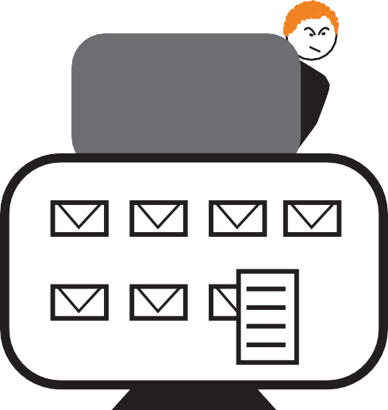

###### **Let us advise you!**

?

Addresses of advice centres are at the end of this booklet.



**This is also cyber stalking:**

##### Stealing the Internet password from victims

Some people are good with computers.

This is how people find the internet password of others. Stalking people can use someone else's password. It's called: **Identity stealing**.

**Identity** means: information that belongs to a person.

Identity details are for example:

* Name
* Internet password
* Address
* Phone number
* Bank account number

So stealing identity can mean:

Stalking people read private things of others. Then stalkers know about others. The stalkers take advantage of this.

###### **Stealing identity is a crime!**

**Do not** let them do this! Protect yourself!

Are you affected?

Report this to the Internet service immediately. The Internet service must protect you.

Also inform the police! **110**

**110**



L

I

Z

E

I

P

O

**Example:**

Martin is an ex-partner of Frauke.

Martin knows Frauke's Internet password. And Martin uses the password.

Martin orders stuff on the Internet.

Frauke gets invoices for things she ordered.

But Frauke herself did **not** order **anything.**

Frauke must **not** pay the bills.

**Frauke must inform the police!**

**!**

**Another example:**

Franz and Paul used to be good friends. Franz knows Paul's Internet password. Franz uses Paul's password.

Franz signs Paul up for Twitter.

Franz writes bad messages on Twitter. Many people read that.

Readers believe:

Paul wrote the bad messages.

It is hurting Paul.

**Paul needs to inform the Internet service!**

The Internet service must

delete the bad stuff immediately.

**!**



**How can you**

### protect yourself from cyber-stalking?

###### **Be attentive on the internet.**

Share private information **only** with trusted people. You know the person in reality?

**Only then** exchange messages!

You know the person **only** from the Internet? Then prevent the contact!

###### **Keep your identity secret.**

Do **not** post personal information on the Internet. Personal details also include photos of yourself and photos of relatives and acquaintances.

You need to provide information on the Internet? Check everything carefully first.

Only then send the message.

**Example:**

Are you attending a particular event? Do **not** write that on the Internet.

**Only** trusted persons should know your whereabouts.

**Do not inform about your private life.**

**Do not** post your appointments on the internet.

###### **Protect your mobile phone and computer!**

Use one password for the phone and another password for the computer.

Keep every password secret! Only allow trusted persons to access your mobile phone and computer!

Change each password after a certain period of time.

**Your children use the Internet?**

Then discuss protective measures with the children!



### Are you affected by cyber-stalking?

**Then what can you do about it?**

##### Demanding an end to cyber-stalking in writing

Demand in writing from the stalker:

The cyber stalking has to stop!

This is called a **written injunction declaration**. Legal advice can support you.

Does the stalker continue anyway?

Then a court can punish the stalker.

The stalker will probably get fined.

Change the email address!

That is a piece of cake.

Counselors or advisors can help.

**Emails from the stalker are evidence.**

Keep the evidence.

You can save the mails.

**Someone ordered stuff with your password.**

You are going to pay for these things?

Do **not accept these** things! Send parcels back immediately. Tell your neighbours too!

##### Somebody bad-mouthed your identity?

Someone wrote fake news? Someone sent bad pictures on the internet? You are affected by the messages or pictures? Report it to the internet service!

The Internet service needs to remove bad stuff!

###### **Talk to the police.**

You feel threatened? Go to the police!

Have courage!

The police can protect you!

**110**



L

I

Z

E

I

P

O

##### The law protects victims of cyber-stalking.

They have a right to be protected!

The law specifies protective measures.

Some protective measures you must apply for.

Legal advisors can provide support. The legal advice costs money?

You can apply for legal-aid assistance.

###### **Let us advise you!**

?

Advice centres against violence always help.

Addresses of advice centres are at the end of this booklet.

## **What can you do against domestic violence?**

**A life without violence is possible!**

#### **You should be in control of your life.**

You have children?

Then you are also responsible for the children. Violence should **not** be in your life.

You feel affected by domestic violence?

Trust your feelings! Defend yourself against the violence! How can you defend yourself?

Let us advise you!

You may have to make new choices.

The choices can change your life situation.

Some examples:

Maybe you decide to separate from your partner or to find a new job.

Or you can choose a new kindergarten for your child.

You have many choices in life.

You can do this!

###### **Have courage!**

You and your child can escape the violence.

###### **Keep yourself safe!**



**Courage**

You yourself know the violent person particularly well. You are afraid of another act of violence?

Trust the fear. Take care of your safety!

###### **Talk to people you trust!**

This can be relatives or friends.

These can also be counselors or advisors. Let them help you!

Let them protect you! The protectors are listening!

###### **You can use protection**



**at the women's shelter!**

Are you or your children in danger? A women's shelter protects

Victims of Domestic Violence.

Women and their children can live in the women's shelter for a while.

###### **Let us advise you!**

?

Addresses of advice centres and

of women's shelters are at the end of this booklet. 63

**What are you always supposed to do,**

**if you are affected?**

**!**

###### **Write everything down**

You may have to explain everything in detail later.

Therefore, always write down:

* **When** exactly was the violent situation?
* **Who** is affected?
* **Who** is a witness?
* **Where** did the violent crime happen?
* **What** exactly happened?
* **How** did the person do violence? For example:

The violent person hit? What did the violent person use?

Did the violence person hit with hands?

Or with an object?

Written reminders are also called: **notes**. Keep all notes in a safe place!

**!**

###### **Collect evidence**

You want to escape the violence.

You have a right to protection from violence. You must apply for protection.

Then you must prove the acts of violence. Therefore, collect all the evidence.

###### **Make a list of all the evidence.**

Keep the list safe.

Put the evidence in a safe place. You filed for protection?

Then a court will consider the request. You may have to show the evidence.

###### **How to collect evidence**

Some examples:

* + Keep naughty letters.
  + Save bad mails with date.
  + Save bad phone calls.
  + You have received false invoices? And you have **not** ordered **anything**?

**Do not** pay!

But keep the invoices!

* + Take proof photos.
  + The violent person hurt you?

Get the report from the victim's outpatient clinic.

* + The police helped you?

Get police reports.

* + You have participated in an event?

You were molested there?

The admission ticket proves your participation.

* + Write it all down.

So you can answer questions later.

**Pack an emergency suitcase !**

Have you experienced violence in a relationship? Then violence can happen again.

A violent situation is an emergency.

In an emergency, you need to quickly leave the apartment. Therefore, provide now for the emergency.



**COURAGE**

Pack an emergency suitcase.

Put the suitcase in a safe place.

**Safe place** means:

* The violent person can not get there.
* You need the suitcase?

Then you can get the suitcase quickly.

A **safe place** is for example

the home of a trusted person.

There is a packing list on page 147 in the booklet.

On the packing list are important things. Pack **only** the important things in the suitcase.

This is what the packing list lookslike:

|  |  |  |
| --- | --- | --- |
|  |  |  |
|  |  |  |

**Write a memo !**

In difficult situations, you need to act quickly. Then a memo can help.

On page 145 in the booklet is a memo.

**There are questions on the memo.**

Read the questions well. Think about answers.

Write down all the answers on the memo.

Always have the memo with you.

You are going to be in danger?

Then use the memo. This is what the memo looks like:

Memo:

These emergency numbers are important:

Police:

Fire and Rescue Service:

Who can I trust?

Who do I talk to in difficult situations?

Who helps me in an emergency?

My trusted persons are:

Where can I go when I am in an emergency?

I discussed that with my trusted person:

I go to:



###### **Medical assistance in an emergency**

Important in case of injuries caused by physical violence: Go to the doctor!

Get the report from the **victim's outpatient clinic**. It is important evidence.

Every doctor has a duty of confidentiality!

You can show all the injuries. You can talk about the violence!

###### **What is a victim advice center?**

**Ambulance** means:

A doctor examines and helps. Then you can leave again.

The **Victim Outpatient Clinic** is an emergency service.

Those affected by acts of violence get help quickly.

The doctor writes a report. The doctor's report remains secret.

The doctor's report stays at the victim's clinic. The victim outpatient clinic belongs to the **Forensic medicine**.

The **forensic medicine** supports the court

in solving violent crimes.

Meaning:

Will the court need evidence later?

Then the court may read the doctor's report. But you must consent.

The victim outpatient clinic is free of charge.

###### **Where is there a victim outpatient clinic?**

* + Rostock

Institut für Rechtsmedizin der Universität Rostock

(Institute for Forensics of the University of Rostock)

St.-Georg-Straße 108

18055 Rostock

* + Schwerin  
    Institut für Rechtsmedizin der Universität Rostock

Institute for Forensics of the University of Rostock

Schwerin Branch Office Obotritenring 247

19053 Schwerin

* + Greifswald  
    Institut für Rechtsmedizin  
    Universitätsklinik Greifswald

**(Institute for Forensics,** University Hospital Greifswald) Kuhstraße 30

17489 Greifswald



# You have the right to be

## **protected from violence!**

#### **The Violence Protection Act.**

Victims of violence have protection rights.

**§**

The police and the courts must protect the victims.

In case of danger, the police can protect immediately.

A law determines further protective measures. The law is called: **Violence Protection Act**.

You must apply for the further protective measures. Then a court must decide.

The law gives the court several options.

##### Claim your protection right !

Advice centres can help.



An **attorney** can also advise and help. An attorney is:

**§**

A lawyer or a legal counsel.

A lawyer knows the law well.

Legal assistance costs money?

You can apply for financial aid.

Counselors and advisors can help.

###### **Let us advise you!**

?

Addresses of advice centres are

at the end of this booklet.

**How can you demand your protection-right?**

##### In an emergency: Call the police!

The police must come at once.

The emergency number for the police is: **110**.

###### **110**



L

I

Z

E

I

P

O

Report to the police: What exactly happened.

The law allows the police to take various protective measures. For example:

The police can issue a ban.

Then the violent person has

to leave the home of those affected.

The police can immediately decide on protective measures. These protective measures are valid for up to 2 weeks.

##### In case of serious injuries, also call the rescue service!

The emergency number of the rescue service is: 112

**112**

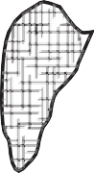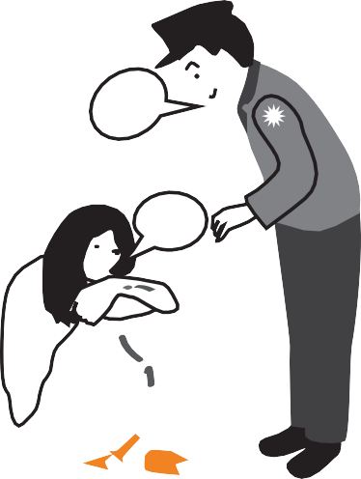

###### **You can make a report**

You may want further protection later.

Then the **police report is** important.

A police report means:

You blame the violent person.

You report the act of violence to the police.

The police are writing a report on the violent crime. You sign it.

The police have to keep the report forever.

The police are informing a court.

The court can punish the violent person.

The police can also inform an advice centre.

The counselor quickly gets in touch with the person affected.

An affected person has serious injuries?

Then the police make a report immediately.

**Here is what you need to know about a police report:**

The police come in an emergency?

Then you can make the report immediately.

You can also decide later on whether or not to report it.

You can make the report orally or in writing.

**Where can you file a report?**

* With the police:

You can call.

You can also go to any police station. You can come at any time.

* At the district court.

##### You have the right to further protection.

You experience violence again and again? You are afraid?

**§**

You can get further protection. Then it is important:

You made a report.

Or you make a report as soon as possible.

You can get advice for the report.

?

At an advice centre against violence or at a legal aid centre.

###### **This is important: !**

For further protection, you must file a motion. You must file the motion with the local court. A counselor can help. Also hand over all evidence!

You wrote down notes? Then hand in the notes too!

##### A court will consider the motion.

That can take a few weeks. The court examines evidence.

The court may question witnesses.

Your trusted persons can also be witnesses.

Perhaps the police and the court have further questions. Then the police can invite you to an **interrogation.** You have to go to the interrogation.

**That is what you need to know about an interrogation:**

**Interrogation** means:

Police are asking questions about the violent crime. Your answers can be very important! But you do **not have to** answer.

Let us advise you on this!

You can take a trusted person with you. A counselor can also accompany you.

###### **Let us advise you!**

?

Addresses of advice centres are

at the end of this booklet.

##### A court will decide on further protection.

The court has considered the motion? Then the court can decide.

The court's decision is called an **order**.

The court has agreed to further protective measures? Then the further protective measures apply.

These protective measures are valid for up to 6 months.

What happens after 6 months?

You can then also get further protection. However, you must submit a new motion.

###### **It is also possible:**

**There is a court case.**

Meaning:

The court must first deliberate. Perhaps the court has more questions.

You may also have to come to court. In the end, the court decides.

The decision is called a **verdict**.

Maybe the court will also punish the violent person.

###### **Domestic violence is a criminal offense.**

Is the violent person guilty?

Then the court determines a penalty.

### How can you as an affected person claim your right to protection?

###### **Example:**

Klara and Niklas are partners.

Niklas beats up Klara. The violence hurts Klara. Klara calls the police.

The police decide immediately:

Niklas is **not** allowed to enter Klara's apartment for 2 weeks.

Klara is filing a report with the police.

Niklas has been hitting a lot of times. Klara wants to be left alone at last.

Klara makes a motion for further protection.

A counselor supports Klara.

The court considers the motion.

Then the court decides:

Niklas must never enter Klara's apartment again.

**Another example:**

Lukas cheated on Julia in money matters. Lukas also hit.

These are punitive acts.

Julia made a report. Julia wants protection.

That is why Julia filed a motion. Julia filed the motion with the court. The court quickly makes an order: The court determines protective measures.

For example: Lukas must leave Julia alone. He is **not** allowed to visit Julia.

In addition, the court examines: Is Lukas guilty?

Then Lukas must be punished Therefore the court has more questions. Julia has to go to an interrogation.

Has the court examined all the evidence? Then Julia gets an invitation: Julia must come to court.

Julia needs to answer more questions.

Only then the court decides: Lukas gets a punishment.

**What happens in a court case?**

An affected person filed a report.

The police have informed the court.

The competent department of the court is called: Prosecution Office.

The court must consider:

* Does the person affected need to be given protection?
* Is the violent person guilty?
* Is the crime punishable?

The law determines ways to do this.

The court examines evidence. The court questions witnesses.

Maybe the court needs more information? Then the police will help.

The police may:

* See the homes of persons affected.
* Read mails and text messages from persons affected.
* Ask neighbors and friends.
* Ask for doctor's reports.

In the end, the court must decide. That is why there is a **trial**.

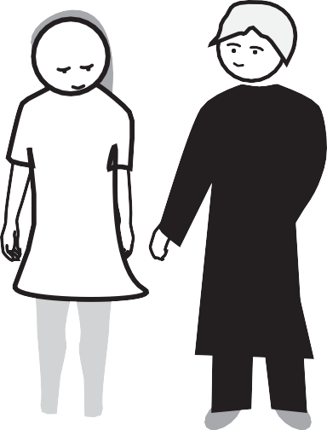

**§**

###### **What is a trial in court?**

A trial is the conclusion of a court proceeding. That means:

The court must decide. Therefore, the court must advise.

There are one or more appointments in court. Then they all have to come to court:

* + The person affected and his or her legal counsel
  + The person committing the crime and his/her legal assistance
  + The judges
  + The witnesses

A judge presides over the trial.

The judge questions all participants.

Then the court decides on guilt and punishment.

The court may also determine further protective measures. The decision in a lawsuit is called: **verdict**.

Another word for trial is: **hearing**.

**§**



###### **What you should know about a trial**

When do you have to come to a trial? You will receive an invitation.

**Only** then do you have to come to court.

You may have to come on different days.

A trial can take longer.

You can take a trusted person with you. A counselor can also accompany you.

The judge and others have questions about the violent crime. Do you have to answer all the questions?

No. But your answers are important. Therefore, let yourself be well advised!

###### **This is important: !**

You need legal assistance.



Legal counsel provides advice and support.

Legal counsel represents your interests in court.

**§**

Legal assistance costs money?

You can apply for financial aid.

Let us advise and support you!

**A process can be very exhausting**

You need a lot of strength.

Therefore, let us accompany you!

You can take a trusted person with you.

You can also get **trial guidance.**

The court must allow trial guidance.

That is why you need to make an application. Get advice on this!

?

Advice centres against violence or your legal adviser can give advice!

**What is trial guidance?**

A trial guidance supports those affected

...in stressful situations in court. That gives courage!

The supporter is a person with special training.

The person has learned a lot about people's feelings.

Therefore, the person has a lot of understanding.

The difficult word for the profession is:

**Psycho-social guidance in trials.**

**Psycho** means: understanding people's feelings.

**What are protective measures**

# for persons affected

## **by domestic violence?**

We give some examples.

Counselors and advisors know more about this.



##### The law protects victims of violence

You are afraid of a violent person?

Do you want protection for yourself and for your children?

The law gives police and court various means of protection.

In an emergency, the police may determine protective measures immediately. Emergency means:

* The violence seriously injured one person involved.
* The health of those affected is at risk.
* The freedom of affected persons is in danger.
* An affected person's life is in danger.

Protective measures in case of emergency are valid for 2 weeks.

A court may order further protective measures. You must apply for further protective measures.

Then a court decides on the motion.

##### How can the police protect you?

These protective measures may be determined by the police   
immediately:

* + **Eviction order** and
  + No-contact order.

The protective measures apply to specific areas.

For example: for the home of persons affected.

Stay-away order means:

The violent person must leave the apartment immediately.

The police take the apartment key of the violent person. The violent person has to stay away for 2 weeks.

No-contact order:

The violent person is **not** allowed to enter the apartment. The no-contact order is valid for 2 weeks.

**!**

**This is important:**

You want the stay-away order

or no-contact order to be valid for a longer period of time?

Then you need to file a motion.

Stay-away order and no-contact order can also apply to other areas of life,

for example: for garden or office.

##### You must be proactive to help against violence!

Adhere to the protective measures yourself!

The violent person has a ban on entering? The violent person comes anyway?

Then do not let the violent person in! The violent person is **not** allowed to fetch things either. Do **not** allow it!

The violent person does **not** comply with the protective measures? That is punishable.

Then inform the police immediately! Make another report.

The police report may be important later.

Ask for help.

###### **Let us advise you!**

?

Would you like to know more about protection options? Advisors know what to do.

Addresses of advice centres

are at the end of this booklet.

##### The police may control

The violent person does **not** comply with the ban? Then the police may:

* + arrest the violent person or
  + impose a fine.

###### **The police provide counselling against violence**

You called the police in a violent situation. The police have noticed that you are in danger.

Then the police make protective measures.

After that, the police inform

an **intervention centre against violence**. **Intervention** means: to take action quickly.

###### **110**



L

I

Z

E

I

P

O

An **intervention centre** quickly takes care of those affected.

That is why a counselor comes forward.

The counselor offers advice and help. Affected persons must always agree.

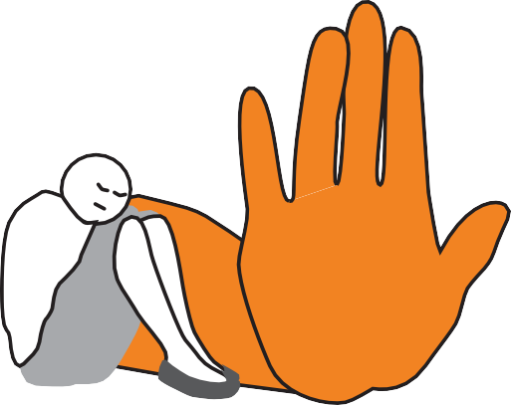

**STOP**

That, too, can be determined by the police:

The violent person must seek counselling. The counselling is called: **anti-violence counselling**. **Anti-violence** means: against violence.

The violent person should learn, 89

how a life without violence is possible.

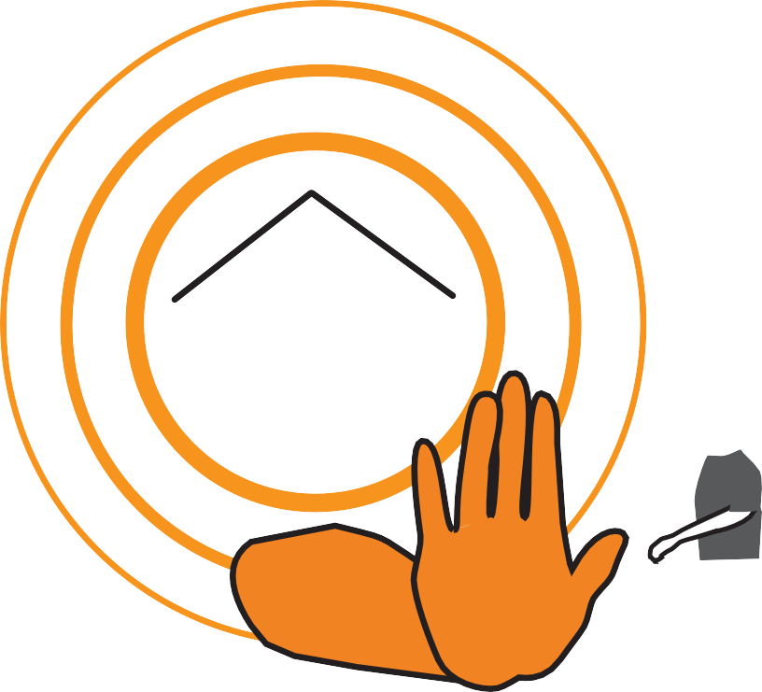

**STOP**

##### How can the court protect you?

The court has more options than the police. The court can also determine measures.

But you must apply for the measures. The court must first consider the motion.

You can **not** do that right away.

Is a person in danger?

Then the court decides quickly.

The violent person does **not** comply with protective measures? Then the court can punish.

**!**

**This is important**

##### in the case of no-contact and stay-away orders

These measures of the police are valid for 2 weeks.

The court may extend these measures.

The court may determine further measures:

* + **No-contact and stay-away order,** and
  + Housing allocation

**No-contact and stay-away order means:**

The violent person must leave the victim alone.

The violent person may **not**:

* + get close to the person in question.
  + call the person affected.
  + write to the person affected.

The no-contact and stay-away rule applies everywhere.

Housing allocation means:

Do the person affected and the violent person live together?

Then the violent person must leave the apartment.

The person affected gets the apartment.

The violent person must hand over the key.

The violent person is also **not** allowed to visit.

**An example of housing allocation**

Lara and Jan live together. Jan is violent all the time. The violence must stop.

That is why Lara is getting counseling.

Then Lara files a motion with the district court. The counselor helps.

Lara applies for **housing allocation**.

The court agrees:

Jan has to leave the apartment.

He also has to hand in the key. Lara is allowed to stay in the apartment.

**!**

**This is important for you when it comes to a housing allocation**

You have the housing allocation.

**Your ex-partner had to move out:**

How long will you be allowed to stay?

The law determines various options.

Option 1:

You own the apartment alone?

Or you alone have signed the lease? Then you can stay in any case.

Option 2:

Both persons own the apartment together?

Or both have signed the lease? Then you can stay for 6 months.

But the ex-partner can claim rent money.

You want to stay in the apartment?

Then you have to pay money to the ex-partner. Or you alone have to pay the rent money.

You may also need to file a motion. Do that immediately!

The court takes time to process it.

Get good advice!

?

Counselors can also help with the motion.

# Where can victims find advice and protection?

**These bodies shall support**

**persons affected by domestic violence:**

* In emergency situations: Emergency phones
* Police
* Advice centre for persons affected by violence
* **Intervention Centre** against violence
* Women's shelter
* Social Welfare Office or Youth Office
* Legal Advice Centre
* Lawyer or attorney at law
* Advice centre for violent persons
* Family Court

###### **Important to know: !**

Almost all advice centres work free of charge.

Legal advice or trial cost money?

You can apply for financial aid.

Advisors or counselors will help with the application.

**Emergency telephones for affected persons**

###### **Police:**

 **110**

**110**



L

I

Z

E

I

P

O

**Fire and Rescue Service:**

 **112**

###### **112**

**What does intervention against violence mean?**

**Intervention** means: help quickly.   
Intervention is more than advice.

Intervention is: help in need.

Have you been affected by violence?

You need advice and help very quickly?

Then employees of intervention centres take care of you.

**Helpline "Violence against women": 08000 - 11 60 16**

Any affected woman can call:

* Affected persons from many countries:

Consultation is available in many languages.

* The religion of the persons affected does not matter.
* The opinion of persons affected about politics and

living together in the society does not matter.

* The sexuality of persons affected does not matter. Sexuality can be:
  + Woman and man love each other
  + Woman loves woman

Experts advise against violence on the helpline. Victims can call the helpline at any time.

The phone is safe: no one can listen in.

The conversation remains secret.

The names of those affected also remain secret.

The telephone is free of charge. The telephone is barrier-free.

##### Logo der Kinderschutzhotline Mecklenburg-Vorpommern Child Protection Hotline:

 **0800 – 1 41 40 07**

Experts provide advice on the child protection hotline:

The professionals have experience with violence against children.

The experts work for the Arbeiter-Samariter-Bund in Rostock.

The Arbeiter-Samariter-Bund is an aid organisation.

The abbreviation is: ASB.

A person needs protection? Then the ASB can help.

###### **This is important: !**

Special help is needed for difficult problems.

Please inform the police or the youth welfare office.

##### You care about children in need?

These can be emergency situations:

* + No one cares about the children. The children look bad.
  + There is a terrible fight in the family.
  + The children experience violence.
  + The children see and hear acts of violence.

You can call the child protection hotline at any time!

The conversation remains secret.

The names of those affected also remain secret.

The phone is safe: no one can listen in. The phone is free of charge.

### Various advice centres

##### Advice centres

###### **against domestic violence**

All persons can be affected:

* Women, men and children
* People from all countries
* Religion does not matter.

##### How do the counselors provide support?

Giving you advice:

* This way you can protect yourself and your loved ones.
* Information about your protection rights

Supporting you:

For example: Help with applications and motions

Accompanying you:

The counselors accompany in difficult situations, for example: to authorities or to court

Contacts:

The counselors can help with contacts, for example:

* Contact to help facilities
* Addresses of professionals for legal matters

The consultation is secret.

You can talk about anything.

Counselors and advisors do not tell anybody.

Some questions are better answered by professionals. For example:

A legal adviser knows the law well. Sometimes counselors therefore have to ask experts. The persons affected must allow this.

**The consultation is free of charge.**

##### Where do you get the advice needed?

You can decide that for yourself. Possible, for example:

* + At the advice centre
  + At your home
  + At another place of your choosing.
  + On the phone.

You can call from home

or from another phone.

###### **Let us advise you!**

?

Advice centres are in many places in Mecklenburg-Vorpommern.

Addresses are at the end of this booklet.

Choose an advice centre near you.

**Intervention Centre**

##### against domestic violence and stalking

Intervention means:

**You'll get help very quickly.**

Have you been affected by violence?

You need advice and help very quickly?

Then female employees of intervention agencies take care of them.

Those affected always have a say in the decision. Those affected must always agree.

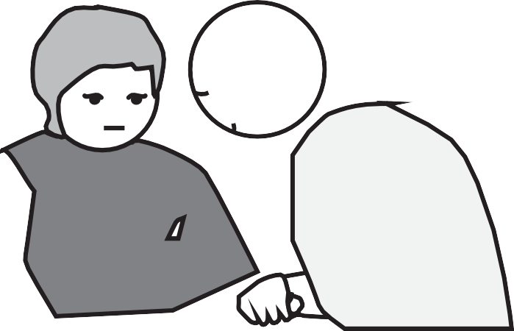

**How do counselors at intervention centres help?**

Giving you advice

The counselors advise those affected.

The counselors discuss with the persons affected what to do:

* + How can those affected protect themselves and their children?
  + What help do those affected need?
  + Who can help?
  + What protection options does the law offer?
  + Advice on applications

Supporting you

The counselors take care of help.

The counselors have addresses of help facilities.

The counselors help with the contacts.

Accompanying you

The counselors accompany you to appointments. For example: to authorities or to court.

Conversations

Do the persons affected agree?

Then the counselors also talk to other people. The counselors do **not** disclose **anything** else.

All conversations remain secret.

Maybe if there are problems, further conversations will help. Do the persons affected agree?

Then the female employees also talk to others, for example:

* + With trusted persons of persons affected.
  + With the violent person.
  + With professionals.

**That is what conversations are about**

##### with the violent person

The violence must stop.

Only then can the partners live well together. Therefore, the violent personmust learn,

how a life without violence is possible.

###### **That is what talking to professionals is all about, for example:**

* Health advice
* Doctor's report
* Legal advice if you want a divorce
* Legal advice when a court asks questions
* Bank counselling when a person has money debts
* Counselling for people suffering from alcoholism

##### Where do you get the advice?

You can decide that for yourself. That is possible, for example:

* At the Intervention Centre against Violence
* At your home
* You may even choose another place.

###### **How do you reach an intervention center?**

You have experienced domestic violence.

You called the police.

The police realize: you are in distress.

Then the police make protective measures.

After that, the police will inform an intervention center. You do not have to do **anything** else.

The intervention centre will contact you after a short time.

You can also contact an intervention centre yourself. You can call or write.

You can go there too.

##### There is an intervention centre in these cities:

* + Rostock
  + Schwerin
  + Wolgast
  + Stralsund
  + Neubrandenburg

Choose an intervention centre near you.

Addresses of intervention centres

are at the end of the booklet.

###### **Immediate help for victims of domestic violence: Trauma outpatient clinic**

**Trauma** means: your feelings are seriously hurt.

Trauma is experienced by many victims of physical violence and victims of sexual violence.

They say: The victims are **traumatized**. Traumatized people are sick.

These people need help.

A trauma outpatient clinic is an immediate help center.

Those affected can make an appointment immediately.

5 appointments are free of charge.

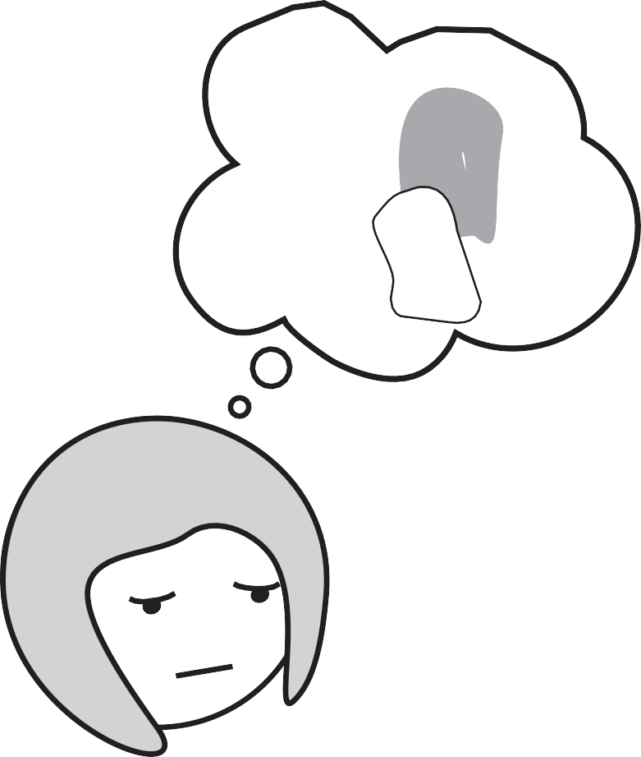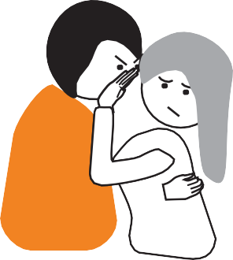

##### There is a trauma outpatient clinic in these towns and cities:

For adults and for children:

* Neubrandenburg
* Schwerin

For adults:

* Greifswald
* Stralsund
* Rostock
* Neustrelitz

For children:

* Röbel
* Ueckermünde
* Anklam

Addresses of trauma outpatient clinics are at the end of the   
booklet.

###### **Women's Shelter**

A women's shelter is a protective facility



**for women and their children.**

Are you a woman affected by violence?

You are afraid of new violence at home?

Then you can live in the women's shelter under protection.

Women and children live together in the women's shelter. In the women's shelter all women are free.

Every woman decides for herself about her own life.

Police or court have determined protective measures. The violent person does **not** comply with the regulations. The violence continues.

Or you are in distress.

Then you can go to a women's shelter. There you will get protection.

The women's shelter is always open for those seeking protection!

You are in danger?

Then you can come at any time.

How long can you stay at the women's shelter? A few days or a few months.

It depends on your needs.

##### How do you reach the women's shelter?

Give us a call!

Or write an e-mail.

Addresses are at the end of this booklet.

##### You're at the women's shelter?

**Where can we go from here?**

You want to live in safety.

That is why you must stand up to violence.

You must make important decisions. The decisions can change your life. Some examples:

Maybe a separation is important. Maybe you need to file a motion. Maybe you need a new apartment.

Residents in the women's shelter want help? Then they will get help.

That is how you get help from the shelter employees:

* They advise and support those affected.
* They help with applications.
* They accompany affected persons to authorities or to court.
* They accompany you in the search for an apartment.
* They support with the children.

##### There is a women's shelter in these cities and towns:

* Rostock
* Güstrow
* Schwerin
* Wismar
* Ludwigslust
* Greifswald
* Stralsund
* Ribnitz-Damgarten
* Neubrandenburg

Addresses are at the end of this booklet. 109

###### **Advice centres against sexualised violence**

Here you can get help for problems with sexualised violence.

The counselors are particularly familiar with the subject.

###### **Who can come for counselling?**

* Men or women
* Children or adolescents
* Friends and acquaintances of persons affected

Do you know a person who is affected? You would like to support the person? You can get advice on this.

However, the person affected must consent.

Or the counseling must be **anonymous.**

**Anonymous** means: you are not allowed to give a name.

##### Counselors can help with:

**Conversations**:

Counselors know problems after sexualised violence.

Counselors understand.

Advice:

* What can you do about the violence?
* Information on protection measures for persons affected
* Counselling for the consequences of sexualised violence

Contacts:

The counselors help with contacts, for example:

* + Help facilities for affected persons
  + Addresses of doctors

Accompanying you:

Counselors accompany to appointments

if that's what the persons affected want.

The consultation is secret.

Counselors **do not** tell anybody else.

##### Where is the counseling?

You can call.

You can also come to the advice centre yourself.

##### These cities and towns have an advice centre against sexualised violence:

* + Rostock
  + Schwerin
  + Greifswald
  + Pasewalk
  + Stralsund
  + Neubrandenburg

Addresses are at the end of this booklet.

###### **Advice centres for violent persons**

Every human being can renounce violence in life.

Some people, unfortunately, have become accustomed to violence.

These people need to change their lives.

They need to solve problems without violence. Even violent people can learn that.

Many violent persons suffer from violence themselves. They wish for a life without violence.

But they **can not do** it alone.

###### **What do advice centres for violent persons?**

Conversations:

What can help the violent person?   
The violent person can tell everything.

She/he can talk about problems.

She/he can also talk about feelings. The counselor gives recommendations.

Advice and support:

The goal is: the violence must stop. Violent persons are mostly men. Then male counselors also do the counselling.

Exercises:

The violent person practices good handling of difficult situations. Counselors support them in this.

The consultation is secret.

**The consultation is free of charge**.

###### **Who comes for counseling?**

Would you like a consultation?

Then you can make an appointment. You can come by.

You can also call.

It is also possible that the police or the court register a violent person.  
The violent person must then participate.

##### How do you reach the advice centre?

Addresses are at the end of this booklet.

###### **These cities and towns have an advice centre for violent people:**

* + Greifswald
  + Güstrow:

Specialist practice for violence counseling and **offender therapy   
Offender therapy** means:

Violent persons practice a violence-free life. Professionals advise and support.

The specialist practice also works

for the district of Ludwigslust-Parchim.



##### ZORA

**Specialist advice centre for persons affected**

##### by human trafficking and forced marriage

ZORA is a special advice centre.

The name ZORA comes from Arabic countries. ZORA means: hope.

The name means: A better life can begin.

German laws protect all those affected by violence in partnerships.

The persons affected do **not** have to be German citizens.

ZORA's counselors have experience with:

* Women's problems,

who have come from other countries

* Human trafficking
* Forced marriage.

Human trafficking and forced marriage

**are criminal offences in Germany.** Unfortunately, many women are affected. ZORA helps those affected.

Zora is an offer of the **AWO**. **AWO** is an abbreviation.

AWO stands for Arbeiter-Wohlfahrt.

##### Let ZORA advise you!

The consultation is secret.

This is the address of ZORA: Postfach 11 01 34

19001 Schwerin

03 85 – 52 19 05 42

01 74 – 920 75 61

[zora@awo-schwerin.de](mailto:zora@awo-schwerin.de)

**What is forced marriage?**

In some countries, women are **not** allowed to determine their lifes. Women are **not allowed to** decide for themselves:

* who they want to marry and
* when they want to get married.

Most of the time, it is determined by a man in the family. For example:

A father chooses a husband for his daughter.

The woman in question is forced into marriage.

This has **nothing** to do with love. This is **forced marriage**.

##### Who is affected by human trafficking?

Almost all of those affected have come from other countries. All over the world people must leave their home country.

There are several reasons for this:

* Maybe there is not enough work.
* Maybe climate change is hurting the home country.

That is why people have very little food.

* Maybe powerful politicians decide.

The politicians have people persecuted and arrested.

Those affected have lived in fear.

They all want a better life in Germany.

##### What is human trafficking?

Human trafficking is fraud.

Human traffickers exploit the plight of affected people. Human traffickers make promises to the affected people:   
Help for a better life.

For example: Good work and a good life in Germany.

Human traffickers demand a lot of money for the help. The persons affected must pay first.

But then human traffickers treat the affected persons badly.

The promises are false.

Many of those affected then have difficulties. Many have no work and no apartment. Many are **not** allowed to stay.

The law does **not** give the right to stay to all those affected.

##### You are not a German citizen? Then this information is important!

You can always ask for police protection!



The police have questions?

You must understand these questions correctly! Therefore, always ask for an interpreter! Do **not** let the violent person translate!

German laws protect you from violence!

?

Good advice is important!

Get legal advice from a lawyer or

by a legal counsel.

You can also get information from ZORA.

Or at an advice centre against violence.

Important information about the right of residence:

You are married?

Your spouse is violent?

Maybe you must leave your spouse. Maybe you will get protection in a women's shelter.

Then it is important:

You must have an **independent right of residence.**

That means:

You are allowed to live in Germany **without** your spouse. You have a decision from the authorities.

You can apply for the independent right of residence.

Let us advise you!

**110**

L

I

Z

E

I

P

O

When can you get the independent right of residence?

You must be married at least 3 years. Or you must apply for **special hardship. Special hardship** means..:

You are in danger.

You need protection from violence quickly.

##### Information for asylum seekers

You live in a facility for asylum seekers?

Are you threatened by domestic violence there?

You want protection at the women's shelter? That is why you want to leave the facility?

Then you have to file a motion.

Information about your place of residence

You are afraid of the violent person? You would like to leave the violent person?

Then you can get protection in a women's shelter. Maybe it is better:

The women's shelter is further away.

You live in another federal state.

You have a **residency requirement**?

The **residency requirement** is a notice from the authority. The notice states:

You are allowed to live in Germany.

But you must live in a certain federal state.   
For example:

You may **only** live in Mecklenburg-Vorpommern. You want to live in another federal state?

Then you need to file a motion.

**This is important: !**

Where do you have to submit the motion?

At the Foreigner's Registration Office.

It is a division of the local authority.

What do you need for the motion?

* All the evidence of violence
* Medical Certificates:

The violent person hurt you? Go to the doctor.

Always get a certificate.

* Police or court ordered protective measures? Then you have received a notice:

You must show every notice.

* You must give good reasons for the motion.

Who can help?

* Advice centres against violence
* Counselors at the women's shelter
* Lawyer or legal counsel



##### CORA

CORA is a **co-ordination office of** the state of Mecklenburg-Vorpommern. **Co-ordinating** means: regulating

CORA cooperates with many institutions providing help.

All of them have experience with domestic violence.

CORA regulates the exchange of experience.

CORA works for example with:

* Advice centres
* Police
* Courts
* Government of Mecklenburg-Vorpommern

These are CORA's tasks:

* Gaining experience with domestic violence
* Coordinate the exchange of experience
* Informing many people about domestic violence   
  In this way, help for those affected should become better and better.

###### **Let Cora help you!**

This is the address of CORA: CORA

Landeskoordinierungsstelle

Heiligengeisthof 3

18055 Rostock

0381 – 40102 29

[cora@fhf-rostock.de](mailto:cora@fhf-rostock.de)

Information on the Internet about domestic violence

 [www.cora-mv.de](http://www.cora-mv.de/)

There you will also find the addresses of all advice centres

and help facilities in Mecklenburg-Vorpommern.

# Addresses

**Here you will find addresses of advice**

**centres and help facilities in:**

**the city of Rostock, in the Rostock district**

Beratungs-Stelle für Betroffene von Häuslicher Gewalt

(Advice centre for persons affected by domestic violence)

Klosterhof 2

18209 Bad Doberan

0174 - 4355843

archeev@web.de

Interventions-Stelle gegen Häusliche Gewalt und Stalking  
(Intervention centre against domestic violence and stalking)

Heiligengeisthof 3

18055 Rostock

For adults: 03 81 – 458 29 38

For children and adolescents: 0176 - 433 43 860

03 81 – 458 29 48



[interventionsstelle.rostock@ stark-machen.de](mailto:interventionsstelle.rostock@fhf-rostock.de)

Beratungs-Stelle für Betroffene häuslicher Gewalt

BeLa  
(Advice centre for persons affected by domestic violence)

Heiligengeisthof 3

18055 Rostock

01 76 – 43 32 69 23

[bela.rostock@stark-machen.de](mailto:bela.rostock@stark-machen.de)

Fachberatungs-Stelle gegen sexualisierte Gewalt

(Expert advice centre against sexualised violence)

Ernst-Haeckel-Straße 1

18059 Rostock

03 81 – 440 32 90



03 81 – 440 32 99

[fachberatungsstelle@stark-machen.de](mailto:fachberatungsstelle@stark-machen.de)

Opfer-Ambulanz Rostock (Victim outpatient clinic)

Institut für Rechts-Medizin der Universität Rostock

(Institute of Forensics, University of Rostock)

St.-Georg-Straße 108

18055 Rostock

0381 – 494 99 01

0172 – 950 61 48

Office hours:

Monday – Thursday 7am to 4m   
Friday 7am to 2:30pm

Trauma-Ambulanz Rostock

(Trauma outpatient clinic)

Klinik für Psychiatrie und Psychotherapie Universitäts-Medizin Rostock  
(Clinic for Psychiatry and Psychotherapy  
University Hospital)

Gehlsheimer Straße 20

18147 Rostock

03 81 – 494 96 89



03 81 – 494 96 88

[pia@med.uni-rostock.de](mailto:pia@med.uni-rostock.de)

**Frauenhaus Rostock (Women's shelter)**

Postfach 10 11 53

18002 Rostock

03 81 – 45 44 06



03 81 – 45 44 07

[frauenhaus@stark-machen.de](mailto:frauenhaus@stark-machen.de)

Frauen-Schutzhaus Güstrow (Women's Shelter)

Postfach 1120

18261 Güstrow

038 43 – 68 31 86



038 43 – 77 34 51

[archeev@web.de](mailto:archeev@web.de)

Beratungs-Stelle für Gewalt-Personen (Advice centre for violent persons)

Gewalt-Beratung, Täter-Therapie und Männer-Beratung

(Counseling against violence, offender therapy and counseling for men)

Platz der Freundschaft 14c 18273 Güstrow

01 60 – 687 27 35

[potthoff@kdw-greifswald.de](mailto:potthoff@kdw-greifswald.de)

Psycho-Soziale Prozess-Begleitung (Psycho-social guidance in trials)

Ernst-Haeckel-Straße 1

18059 Rostock

01 76 – 56 83 35 68

[prozessbegleitung@stark-machen.de](mailto:prozessbegleitung@stark-machen.de)

**Here you will find addresses of advice**

**centres and help facilities in:**

### the city of Schwerin,

**in the district Ludwigslust-Parchim, in the district Nordwest-Mecklenburg**

Beratungs-Stelle für Betroffene von Häuslicher Gewalt

(Advice centre for persons affected by domestic violence)

Rudolf-Breitscheid-Straße 27

23936 Grevesmühlen

038 81 – 75 85 64

[kbst-gvm@awo-schwerin.de](mailto:kbst-gvm@awo-schwerin.de)

Beratungs-Stelle für Betroffene von Häuslicher Gewalt

(Advice centre for persons affected by domestic violence)

Ziegenmarkt 4-7

19370 Parchim

038 71 – 26 59 77

01 51 – 15 30 59 26

[beratung-haeusliche-gewalt@awo-ludwigslust.de](mailto:beratung-haeusliche-gewalt@awo-ludwigslust.de)

Interventions-Stelle gegen Häusliche Gewalt und Stalking

(Intervention centre against domestic violence and stalking)

Platz der Jugend 8 19053 Schwerin



03 83 – 52 19 05 49

Counseling for adults: 03 85 – 52 19 05 41

[interventionsstelle@awo-schwerin.de](mailto:interventionsstelle@awo-schwerin.de) Counseling for children and adolescents:

03 85 – 52 19 05 43

[kinderjugendberatung@awo-schwerin.de](mailto:kinderjugendberatung@awo-schwerin.de)

Beratungs-Stelle gegen sexualisierte Gewalt  
(Advice centre against sexualised violence)

Platz der Jugend 8 19053 Schwerin

03 85 – 555 73 52

[bgsg@awo-schwerin.de](mailto:bgsg@awo-schwerin.de)

Beratungs-Stelle für Gewalt-Personen  
(Advice centre for violent persons)

Gewalt-Beratung, Täter-Therapie und Männer-Beratung  
(Counseling iolence, offender therapy and counseling for men)

Platz der Freundschaft 14c 18273 Güstrow

The advice centre is also for the district of Ludwigslust-Parchim.

01 60 – 687 27 35

[potthoff@kdw-greifswald.de](mailto:zocher@kdw-greifswald.de)

Trauma-Ambulanz Schwerin (Trauma outpatient clinic)

HELIOS Kliniken Schwerin

Klinik für Psychosomatik und Psychotherapie

(Clinic for Psychosomatics and Psychotherapy)

Wismarsche Straße 393 – 397

19049 Schwerin

03 85 – 520 33 91



03 85 – 520 33 29

[simone.rein@helios-kliniken.de](mailto:simone.rein@helios-kliniken.de)

Opfer-Ambulanz Schwerin (Victim outpatient clinic)

Institut für Rechts-Medizin der Universität Rostock

(Institue for Forensics, University of Rostock)

Außenstelle Schwerin (Schwerin branch)

Obotritenring 247

19053 Schwerin

0385 – 73 26 80

Office hours:

Monday – Thursday 7am to 4pm   
Friday 7am to 2:30pm

If the clinic is closed, call in an emergency:

0172 – 950 61 48

Frauenhaus Schwerin (Women's shelter)

AWO Frauen in Not- Frauenhaus Postfach 11 05 63

19005 Schwerin

03 85 – 555 73 56



03 85 – 555 73 58

[frauenhaus@awo-schwerin.de](mailto:frauenhaus@awo-schwerin.de) 129

Frauenhaus Wismar (Women's shelter)

AWO- Frauen-Schutzhaus Wismar Postfach 1462

23957 Wismar

038 41 – 28 36 27



038 41 – 224 29 51

[frauenhaus@awo-wismar.de](mailto:frauenhaus@awo-wismar.de)

Frauenhaus Ludwigslust (Women's shelter)

AWO- Frauenhaus Ludwigslust Postfach 1233

19282 Ludwigslust

038 751 – 212 70

01 71 – 377 51 37

[fh@awo-ludwigslust.de](mailto:fh@awo-ludwigslust.de)

**Here you will find addresses of advice**

**centres and help facilities in:**

### in the district Vorpommern-Greifswald

Beratungs-Stelle für Betroffene von Häuslicher Gewalt

und Gewalt im sozialen Nahraum

(Advice centre for persons affected by domestic violence   
and violence in a social environment)

Breite Straße 6c 17438 Wolgast

038 36 – 237 76 30

01 62 – 251 27 75

[bhg@kdw-greifswald.de](mailto:ohg@kdw-greifswald.de)

Counseling also possible in Greifswald city.

Please register by phone.

Beratungs-Stelle für Betroffene von Häuslicher Gewalt  
(Advice centre for persons affected by domestic violence)

Oskar-Picht-Straße 1

17309 Pasewalk

039 73 – 204 99 75

01 70 – 878 68 48

[kbst-psw@uecker-randow.drk.de](mailto:kbst-psw@uecker-randow.drk.de)

Interventions-Stelle gegen Häusliche Gewalt und Stalking

(Intervention centre against domestic violence and stalking)

Mühlentrift 4

17438 Wolgast

038 36 – 237 27 00

Counseling for children and adolescents: 038 36 – 237 27 01

[ist.anklam@freenet.de](mailto:ist.anklam@freenet.de)

Fachberatungs-Stelle gegen sexualisierte Gewalt Anklam  
(Expert advice centre against sexualised violence)

Friedländer Straße 43

17389 Anklam

039 71– 420 35 17

[anonym@caritas-vorpommern.de](mailto:anonym@caritas-vorpommern.de)

Fachberatungsstelle gegen sexualisierte Gewalt Greifswald  
(Expert advice centre against sexualised violence)

Bahnhofstraße 16

17489 Greifswald

038 34 – 798 31 99

[anonym@caritas-vorpommern.de](mailto:anonym@caritas-vorpommern.de)

Beratungs-Stelle für Gewalt-Personen

(Advice centre for violent persons)

Fachpraxis für Gewalt-Beratung und Täter-Therapie  
(Violence therapy and offender therapy)

Kapaunenstraße 10

17489 Greifswald

038 34 – 231 79 03

01 62 – 251 27 51



038 34 – 231 12 65

[kontakt@gewaltberatung-greifswald.de](mailto:kontakt@gewaltberatung-greifswald.de)

Frauenhaus Greifswald (Women's shelter)

Postfach 3309

17463 Greifswald

038 34 – 50 06 56



038 34 – 83 13 55

[kontakt@frauenhaus-greifswald.de](mailto:kontakt@frauenhaus-greifswald.de)

Opfer-Ambulanz Greifswald (Victim outpatient clinic)

Institut für Rechts-Medizin Universitäts-Klinikum Greifswald  
Forensics Institute, University Clinic of Greifswald)

Kuhstraße 30

17489 Greifswald

038 34 – 86 57 43

Office hours:

Monday – Friday 7am to 3:30pm

If the clinic is closed, call in an emergency:

0172 – 950 61 48: 0172 – 318 26 02

Trauma-Ambulanz Greifswald (Trauma outpatient clinic)

Klinik für Psychiatrie und Psychotherapie Universitäts-Medizin Greifswald   
(Clinic for Psychiatry and Psychotherapy, University Clinic)

Ellernholtzstraße 1-2

17487 Greifswald

038 34 – 86 69 16



038 34 – 86 68 89

[trauma-ambulanz@uni-greifswald.de](mailto:trauma-ambulanz@uni-greifswald.de)

Trauma-Ambulanz Ueckermünde (Trauma outpatient clinic)

AMEOS Klinikum

Klinik für Psychiatrie und Psychotherapie Klinik für Kinder- und Jugendpsychiatrie

(Clinic for Psychiatry and Psychotherapy and Clinic for Children and Adolescent Psychiatry)

Ravensteinstraße 23

17373 Ueckermünde

039 771 – 414 79



039 771 – 414 36

Trauma-Ambulanz Anklam (Trauma outpatient clinic)

AMEOS Klinikum

Klinik für Psychiatrie und Psychotherapie Klinik für Kinder- und Jugendpsychiatrie

(Clinic for Psychiatry and Psychotherapy and Clinic for Children and Adolescent Psychiatry)

Hospitalstraße 19

17389 Anklam

039 71 – 834 64 64



039 71 – 834 51 08

**Here you will find addresses of advice**

**centres and**

### help facilities in:

### the district of Vorpommern-Rügen

Beratungs-Stelle für Betroffene von Häuslicher Gewalt

(Advice centre for persons affected by domestic violence)

Bahnhofstraße 27 18528 Bergen auf Rügen

038 38 – 20 17 93

038 38 – 828 76 47



0171 – 371 06 94

[frauenberatung@jugendhilfe-ruegen.de](mailto:frauenberatung@jugendhilfe-ruegen.de)

Interventions-Stelle gegen Häusliche Gewalt und Stalking  
(Intervention centre against domestic violence and stalking)

Jungfernstieg 14

18437 Stralsund



038 31 – 30 77 52

[interventionsstelle.stralsund@stark-machen.de](mailto:interventionsstelle.stralsund@stark-machen.de)   
Help phone for adults:

038 31 – 30 77 50

Help phone for children and adolescents: 038 31 – 33 77 51

Beratungs-Stelle für Betroffene häuslicher Gewalt

(Advice centre for persons affected by domestic violence)

BeLa (Stralsund und Grimmen)

Jungfernstieg 14

18437 Stralsund

01 76 – 74 70 83 35

bela.vorpommern@stark-machen.de

Beratungs-Stelle für Betroffene von sexualisierter Gewalt

(Advice centre for persons affected by sexualised violence)

MISS.

Frankendamm 5

18439 Stralsund

038 31 – 667 93 63



038 38 – 82 88 33

[kontakt@miss-beratungsstelle.de](mailto:kontakt@miss-beratungsstelle.de)

Counseling is also possible in Ribnitz-Damgarten and in Bergen on Rügen island.

Please register by phone.

Trauma-Ambulanz Stralsund

HELIOS Hanse-Klinikum Stralsund

Klinik für Psychiatrie und Psychotherapie der Universitäts-Medizin Greifswald  
(Clinic for Psychiatry and psychotherapy, University Hospital

Knieperdamm 2

18435 Stralsund

038 31 – 356 81 00



038 31 – 356 81 05

[sek_frey@uni-greifswald.de](mailto:sek_frey@uni-greifswald.de)

Frauen-Schutzhaus Stralsund (Women's shelter)

Postfach 1316

18403 Stralsund

038 31 – 29 28 31



038 31 – 29 28 32

[fsh-hst@awo-vorpommern.de](mailto:fsh-hst@awo-vorpommern.de)

Frauenhaus Ribnitz-Damgarten (Women's shelter)

Postfach 1047

18301 Ribnitz-Damgarten

038 21 – 72 03 66



038 21 – 70 76 98

[fsh-rd@awo-vorpommern.de](mailto:fsh-rd@awo-vorpommern.de)

Psycho-soziale Prozess-Begleitung (Psycho-social guidance in trials)

Frankendamm 5

18439 Stralsund

038 31 – 667 93 63



038 38 – 82 88 33

[kontakt@miss-beratungsstelle.de](mailto:kontakt@miss-beratungsstelle.de)

Beratungs-Stelle für Gewalt-Personen (Advice centre for violent persons)

Gewaltberatung, Tätertherapie und Männerberatung  
Counseling against violence, offender therapy, counseling for men

Lindenallee 35

18437 Stralsund

01 51 – 74 44 00 47

zocher@kdw-greifswald.de

**Here you will find addresses**

**of advice centres and**

**help facilities in the district**

#### **Mecklenburgische Seenplatte**

Beratungs-Stelle für Betroffene von Häuslicher Gewalt

(Advice centre for persons affected by domestic violence)

KLARA

Lange Straße 35

17192 Waren

039 91 – 16 51 11



039 91 – 63 38 89

[klara@diakonie-malchin.de](mailto:klara@diakonie-malchin.de)

Beratungs-Stelle für Betroffene von Häuslicher Gewalt

(Advice centre for persons affected by domestic violence)

Am Hanseufer 2

17109 Demmin

039 98 – 285 49 08



039 98 – 285 60 27

[bohg@awo-demmin.de](mailto:bohg@awo-demmin.de)

Interventions-Stelle gegen Häusliche Gewalt und Stalking

(Intervention centre for persons affected by domestic violence   
and stalking)

Helmut-Just-Straße 4

17036 Neubrandenburg



03 95 – 555 33 59

For adults:

03 95 – 558 43 84

[interventionsstelle-nb@web.d](mailto:interventionsstelle-nb@web.de)e For children and adolescents:

03 95 – 776 87 25

[kijub-nb@web.de](mailto:kijub-nb@web.de)

Beratungs-Stelle für Betroffene von sexueller Gewalt

(Advice centre for persons affected by sexualised violence)

MAXI

Helmut-Just-Straße 4

17036 Neubrandenburg

03 95 – 570 66 61

[bsmaxi@gmx.de](mailto:bsmaxi@gmx.de)

Frauen- und Kinder-Schutzhaus (Women's and children's shelter)

Postfach 400 208

17022 Neubrandenburg

03 95 – 778 26 40

01 60 – 99 26 92 05

[fksh-nb@gmx.de](mailto:fksh-nb@gmx.de)

Psychosoziale Prozessbegleitung (Psycho-social guidance in trials)

Helmut-Just-Straße 4

17036 Neubrandenburg

03 95 – 570 66 61

[bsmaxi@gmx.de](mailto:bsmaxi@gmx.de)

Trauma-Ambulanz Neubrandenburg (Trauma outpatient clinic)

Dietrich-Bonhoeffer-Klinikum

Klinik für Psychiatrie und Psychotherapie   
(Clinic for Psychiatry and Psychotherapy)

Salvador-Allende-Straße 32

17036 Neubrandenburg

03 95 – 775 45 10

[psy@dbknb.de](mailto:psy@dbknb.de)

**Trauma-Ambulanz Neustrelitz** (**Trauma outpatient clinic)**Dietrich-Bonhoeffer-Klinikum   
Radelandweg

17235 Neustrelitz

03 95 – 775 40 49

Trauma-Ambulanz für Kinder und Jugendliche:

(Trauma outpatient clinic for children and adolescents)

**Neubrandenburg**

MediClin Müritz-Klinikum

Klinik für Kinder- und Jugend-Psychiatrie   
(Clinic for Children and Adolescent Psychiatry)  
Institutsambulanz Neubrandenburg (outpatient clinic)  
Atelierstraße 5-7

17034 Neubrandenburg

03 95 – 43 09 13 29



03 95 – 43 09 13 19

Röbel



MediClin Müritz-Klinikum

Klinik für Kinder- und Jugend-Psychiatrie (Clinic for Children and Adolescent Psychiatry)  
Institutsambulanz Röbel (outpatient clinic)

Stadtgarten 15

17207 Röbel/Müritz

03 991 – 77 19 64

03 991 – 77 19 43

# Help for this booklet

## **Memo:**

**Here is how you can prepare.**

Write down the answers.

#### **Memo:**

##### These emergency numbers are important:

* + Police: 110
  + Fire and rescue service: 112
  + My doctor: _ _ _ _ _ _ _ _ _ _ _ _ _ _ _ _ _ _ _ _ _ _ _ _ _ _ _ _ _ _
  + Women's shelter: _ _ _ _ _ _ _ _ _ _ _ _ _ _ _ _ _ _ _ _ _ _ _ _ _ _ _ _ _ _ _ _ _

###### **Who can I trust?**

Who do I talk to in difficult situations?   
Who helps me in an emergency?

My trusted people are:

Name 1:_ _ _ _ _ _ _ _ _ _ _ _ _ _ _ _ _ _ _ _ _ _ _ _ _ _ _ _ _ _ _ _ _ _ _ _ _ _

Phone :_ _ _ _ _ _ _ _ _ _ _ _ _ _ _ _ _ _ _ _ _ _ _ _ _ _ _ _ _ _ _ _ _ _ _ _ _ _ _

Name 2:_ _ _ _ _ _ _ _ _ _ _ _ _ _ _ _ _ _ _ _ _ _ _ _ _ _ _ _ _ _ _ _ _ _ _ _ _ _

Phone :_ _ _ _ _ _ _ _ _ _ _ _ _ _ _ _ _ _ _ _ _ _ _ _ _ _ _ _ _ _ _ _ _ _ _ _ _ _ _

Name 3:_ _ _ _ _ _ _ _ _ _ _ _ _ _ _ _ _ _ _ _ _ _ _ _ _ _ _ _ _ _ _ _ _ _ _ _ _ _

Phone :_ _ _ _ _ _ _ _ _ _ _ _ _ _ _ _ _ _ _ _ _ _ _ _ _ _ _ _ _ _ _ _ _ _ _ _ _ _ _

###### **Where can I go when I am in need?**

I discussed this with my trusted person.

Going to: _ _ _ _ _ _ _ _ _ _ _ _ _ _ _ _ _ _ _ _ _ _ _ _ _ _ _ _ _ _ _ _ _ _ _ _ _

This is the address

_ _ _ _ _ _ _ _ _ _ _ _ _ _ _ _ _ _ _ _ _ _ _ _ _ _ _ _ _ _ _ _ _ _ _ _ _ _ _ _ _ _ _ _ _ _ Phone: _ _ _ _ _ _ _ _ _ _ _ _ _ _ _ _ _ _ _ _ _ _ _ _ _ _ _ _ _ _ _ _ _ _ _ _ _ _ _ _

This is how I get there: _ _ _ _ _ _ _ _ _ _ _ _ _ _ _ _ _ _ _ _ _ _ _ _ _ _ _ _ _ _ _

_ _ _ _ _ _ _ _ _ _ _ _ _ _ _ _ _ _ _ _ _ _ _ _ _ _ _ _ _ _ _ _ _ _ _ _ _ _ _ _ _ _ _ _ _ _

_ _ _ _ _ _ _ _ _ _ _ _ _ _ _ _ _ _ _ _ _ _ _ _ _ _ _ _ _ _ _ _ _ _ _ _ _ _ _ _ _ _ _ _ _ _

# Packing list in an emergency

###### **This is important:**

You may have to leave the apartment quickly.

Small amounts of luggage is therefore better.

Therefore, pack only the most important things.

On the next page is a packing list.

On the packing list are important documents, for example: certificates and also notices.

It's good if you have everything. You do **not have** everything, you can still cope well. Counselors can help.



|  |  |  |
| --- | --- | --- |
| **What do I need for myself?** | **That's what I have to think about** | **Ready?** |
| My birth certificate |  |  |
| My marriage certificate |  |  |
| My passport |  |  |
| Key |  |  |
| Important  phone numbers |  |  |
| Health insurance card |  |  |
| Account card and savings book |  |  |
| Cash money |  |  |
| Employment contract |  |  |
| Rental contract |  |  |
| My testimonies |  |  |
| Notices from the employment office |  |  |
| Only necessary replacement clothing |  |  |
| Personal things |  |  |
| Hardcopy with passport words |  |  |
| Medicine for myself |  |  |



|  |  |  |
| --- | --- | --- |
| **What does every child need?** | **That's what I have to think about** | **Ready?** |
| Birth certificate |  |  |
| Children's Passport |  |  |
| Prevention instructions from doctor |  |  |
| Child support number |  |  |
| Only necessary clothing |  |  |
| School stuff, report cards |  |  |
| Favorite things, toys |  |  |
| Medicine for the child |  |  |

# Where can you find explanations in this booklet?

**On these pages some terms are explained:**

Anti-violence counselling89

Police report 74

Right of residence117

Advice centres for victims of violence100

Advice centre for persons affected by violence112

Advice centre against sexualised violence110

"Special hardship " 118

Staying-away order 87

CORA120

Cyber stalking50

Women's shelter108

Trial77

Violence affecting children 36

Violence by: Denying Responsibility30

Violence only for power and control34

Violence Protection Act72

Help phone for women98

Identity54

Internet service51

Intervention89

Intervention centre against violence89 , 102

Children help phone 99

Child Welfare Endangerment41

No-contact and stay-away order 91

|  |  |
| --- | --- |
| Physical violence | 22 |
| Human trafficking | 116 |
| Memo | 67, 145 |
| Emergency suitcase | 66, 147 |
| Economic violence | 32 |
| Victim outpatient clinic | 68 |
| Trial | 81 |
| Support | 83 |
| Psycho-social support in trial | 83 |
| Legal aid | 72 |
| Written injunction declaration | 56 |
| Mental violence | 24 |
| Sexualised violence | 26 |
| Social violence | 28 |
| Social network | 52 |
| Stalking | 44 |
| Offender Therapy | 113 |
| Trauma Outpatient Clinic | 106 |
| Interrogation | 76 |
| Stay-away order | 87 |
| Residency requirement | 118 |
| Housing allocation | 91 |
| ZORA | 114 |
| Forced Marriage | 114 |

**Who made this booklet?**

Der Verein Frauen helfen Frauen e.V.

(The association: Women help women)

Ernst-Haeckel-Straße 1

18059 Rostock

0381 – 440 30 77

[ulrike.bartel@fhf-rostock.de](mailto:ulrike.bartel@fhf-rostock.de)



Landeskoordinierungsstelle CORA

(State Coordination Office CORA)

Heiligengeisthof 3

18055 Rostock

0381 – 40102 29

[cora@fhf-rostock.de](http://www.cora-mv.de/) [www.cora-mv.de](http://www.cora-mv.de/)



Capito Mecklenburg-Vorpommern

Translated the booklet into simple language.



Capito Mecklenburg-Vorpommern made the pictures and the layout together with InklusionsDesign.

November 2021